**CEBU INSTITUTE OF TECHNOLOGY**

**UNIVERSITY**

COLLEGE OF COMPUTER STUDIES

Software Requirements Specifications

for

ToolTrack: Smart Solutions for Seamless Tool Management

Paulo Carabuena

Aeron Clyde N. Espina

Nathaniel Salvoro

Change History

Table of Contents

Change History 2

Table of Contents 3

1. Introduction 4

1.1. Purpose 4

1.2. Scope 4

1.3. Definitions, Acronyms and Abbreviations 4

1.4. References 4

2. Overall Description 5

2.1. Product perspective 5

2.2. User characteristics 5

2.4. Constraints 5

2.5. Assumptions and dependencies 6

3. Specific Requirements 7

3.1. External interface requirements 7

3.1.1. Hardware interfaces 7

3.1.2. Software interfaces 7

3.1.3. Communications interfaces 7

3.2. Functional requirements 7

Web Application 7

Mobile Application 9

3.4 Non-functional requirements 10

Performance 10

Security 10

Reliability 10

# Introduction

*The ToolTrack: Smart Solutions for Seamless Tool Management is a user-friendly app that has been developed to track tool borrowing and return. Both the web and mobile parts make it easy for users to check on the availability of tools, borrowing history, and maintenance schedules.  
  
The system provides safe access to the users through login and biometric authentication. It allows users to scan the QR code to easily find and verify tool details. Features such as borrowing requests, return processing, and notifications keep things running and inform the users.  
  
TTS also provides analytics on how the tools are being used and aids in scheduling maintenance and reservations. The system, therefore, makes tool management easier for organizations, saving them time, improving accountability, and keeping resources well-managed.*



## Purpose

* *Describe the purpose of the SRS;*
* *Specify the intended audience for the SRS.*

## Scope

* *Identify the software product(s) to be produced by name (e.g., Host DBMS, Report Generator, etc.);*
* *Explain what the software product(s) will, and, if necessary, will not do;*
* *Describe the application of the software being specified, including relevant benefits, objectives, and goals;*
* *Be consistent with similar statements in higher-level specifications (e.g., the system requirements specification), if they exist.*

## Definitions, Acronyms and Abbreviations

* *provide the definitions of all terms, acronyms, and abbreviations required to properly interpret the SRS*

## References

* *Provide a complete list of all documents referenced elsewhere in the SRS;*
* *Identify each document by title, report number (if applicable), date, and publishing organization;*
* *Specify the sources from which the references can be obtained.*

# Overall Description

## Product perspective

* *Put software product into perspective with other related products. If the product is independent and totally self-contained, it should be so stated here. If the SRS defines a product that is a component of a larger system, as frequently occurs, then this subsection should relate the requirements of that larger system to functionality of the software and should identify interfaces between that system and the software.*
* *A block diagram showing the major components of the larger system, interconnections, and external inter- faces can be helpful.*
* *Describe the modular decomposition of the components using the format below:*

*Module 1*

*Transaction 1.1*

*Transaction 1.2*

*Module 2*

*Transaction 2.1*

*Transaction 2.2*

*. . .*

## User characteristics

* *Describe all user types and their roles and privileges in the system*

## 2.4. Constraints

* *Provide a general description of any other items that will limit the developer’s options.*
* *Regulatory policies;*
* *Hardware limitations (e.g., signal timing requirements);*
* *Interfaces to other applications;*
* *Parallel operation;*
* *Audit functions;*
* *Control functions;*
* *Reliability requirements;*
* *Criticality of the application;*
* *Safety and security considerations.*

## 2.5. Assumptions and dependencies

*This subsection of the SRS should list each of the factors that affect the requirements stated in the SRS. These factors are not design constraints on the software but are, rather, any changes to them that can affect the requirements in the SRS. For example, an assumption may be that a specific operating system will be available on the hardware designated for the software product. If, in fact, the operating system is not avail- able, the SRS would then have to change accordingly.*

# Specific Requirements

## External interface requirements

### 3.1.1. Hardware interfaces

*This should specify the logical characteristics of each interface between the software product and the hard- ware components of the system. This includes configuration characteristics (number of ports, instruction sets, etc.). It also covers such matters as what devices are to be supported, how they are to be supported, and protocols. For example, terminal support may specify full-screen support as opposed to line-by-line support.*

### 3.1.2. Software interfaces

*This should specify the use of other required software products (e.g., a data management system, an operating system, or a mathematical package), and interfaces with other application systems (e.g., the linkage between an accounts receivable system and a general ledger system).*

### 3.1.3. Communications interfaces

*This should specify the various interfaces to communications such as local network protocols, etc.*

## Functional requirements

### Web Application

#### 1.1 Authentication System

***User Login and Registration***

* *Users can create accounts and log in to the system, account activity logs*
* *Role-based access for admin, staff, and users.*

***JWT Token Management***

* *Token generation for secure user sessions.*
* 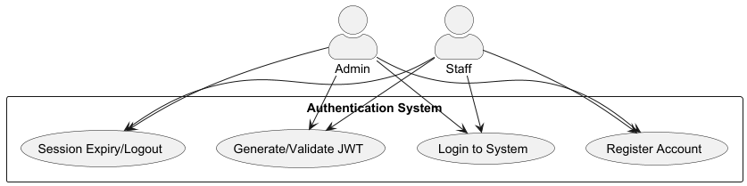*Session expiration handling and automatic logout.  
    
  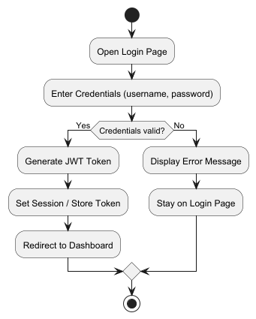*

#### 1.2 Tool Management System

##### **QR Code Operations**

##### Admin can generate QR code to input tool details

##### **Tool Status Tracking**

##### Real-time tool availability

##### Updates on the tool's condition and maintenance status.

##### **Documentation Features**

##### Upload and view tool condition photos and reports.

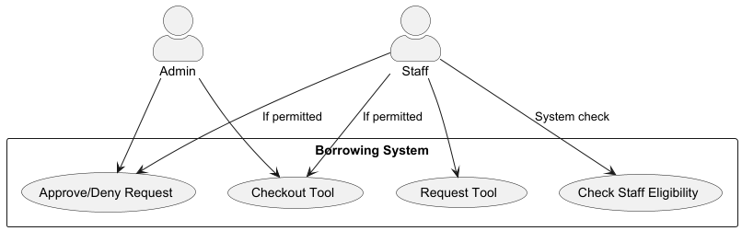

#### 1.3 Borrowing System

***Request Handling***

* *Tool availability check.*
* *Verification of user eligibility to borrow tools.*
* *Allow admin to approve or deny borrowing requests for certain tools*

***Checkout Processing***

* *Set borrowing duration and due dates.*
* *Generate documentation for tool checkout.*

**

#### 1.4 Return System

***Return Processing***

* *Verify tool condition upon return.*
* *Confirm tool location and generate return records.*
* *Allow users to report tool damage during the return process.*

***Documentation Features***

* *Generate return receipts.*
* *Store return photo documentation.*

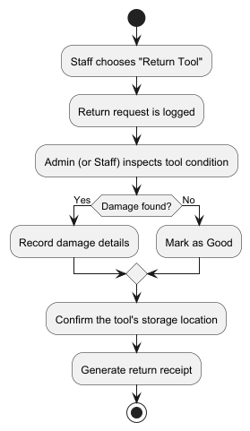

#### 1.5 Notification Service

***Push Notifications***

* *Alerts for due returns, maintenance schedules, and important updates.*

***Email Notifications***

* *Summary notifications for borrowing and return activities.*

#### 1.6 Analytics Service

***Usage Insights***

* *Generate reports on tool utilization patterns*
* *Identify peak borrowing periods and tool demand trends*

***Maintenance Monitoring***

* *Track tools in terms of their condition.*

#### 

### Mobile Application

#### 2.1 Authentication System

***User Login and Biometric Authentication***

* *Fingerprint authentication for fast and secure access.*
* *Session timeout feature*

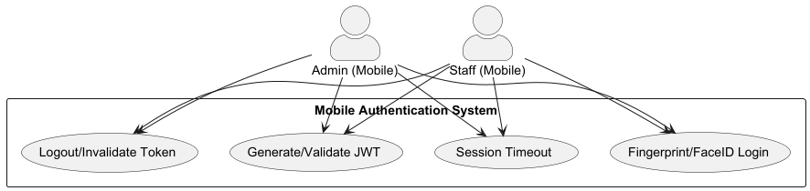

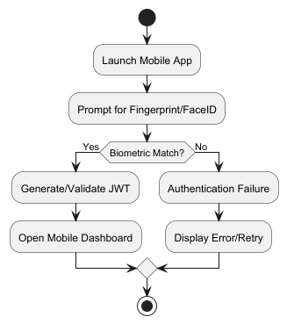

#### 2.2 Tool Management System

***QR Code Scanning***

* *Quick tool identification through QR code scanning and submit request.*
* *View tool details directly on the mobile app.*
* *Option to add text notes about tool conditions*

***Tool Status Tracking***

* *Check availability and location of tools.*

***Documentation Features***

* *Capture and upload photos for condition assessment.*

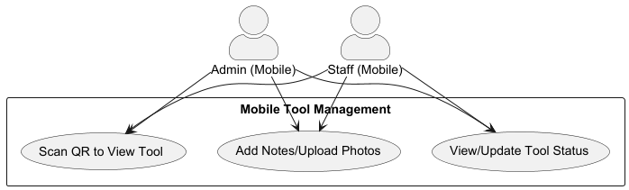  
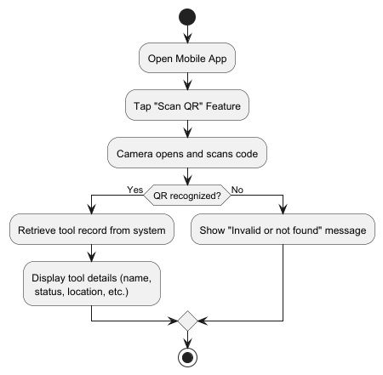

#### 2.3 Service Management

***Tool Request and Approval***

* *Submit requests for borrowing tools.*
* *Automated or manual approval based on user eligibility and tool availability.*
* *Can modify or cancel pending borrow request*

***Checkout Processing***

* *Record tool pickup location and borrower details.*
* *Set borrowing duration and return deadlines.*
* *Generate and share checkout confirmation documents.*

#### 2.4 Return System

***Return Processing***

* *Confirm return location and verify tool condition.*

***Documentation Features***

* *Generate return receipt and upload photo documentation.*

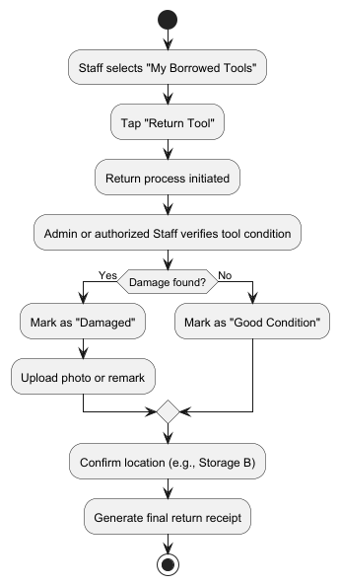

#### 2.5 Notification Service

***Push Notifications***

* *Alerts for due returns, maintenance schedules, and important updates.*

***Email Notifications***

* *Summary notifications for borrowing and return activities.*

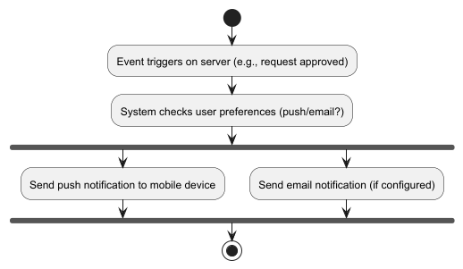

#### 2.6 Analytics Service

***Usage Insights***

* *View individual borrowing history and usage patterns.*

***Maintenance Monitoring***

* *Notifications for tool maintenance requirements.*

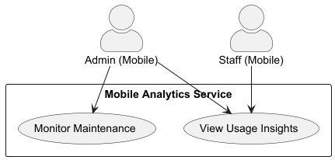  
  
## Non-functional requirements

### Performance

##### Details

### Security

##### Details

### Reliability

##### Details

[QR code API: command “create-qr-code” (generate QR code, QR code generator)](https://goqr.me/api/doc/create-qr-code/)